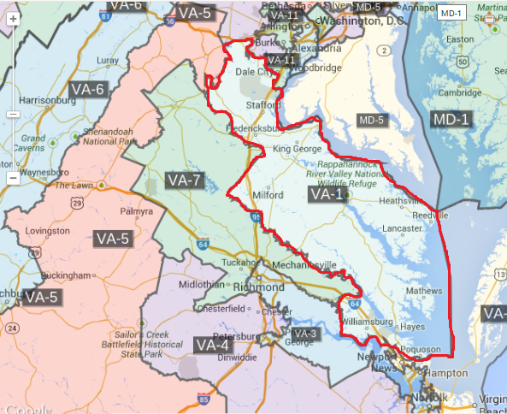
I once met Rob Wittman, the congressman for Virginia’s 1st district, at a US Air Force Association conference in North-West Virginia. He was attending our Military Academy for a USAFA recommendation and nomination for some of my fellow cadets applying to any of the Federal Military Academies. Aside from the recorded bills that he has supported and voted in favor of, in the area, he is known for providing proficient funds to the Virginia Institute for Marine Science, protecting fisheries and waters. On the contrary, a major complaint that he confronts is the toll of the Coleman Bridge that connects Yorktown and Gloucester County. While the typical toll is 75 cents, the bridge is $2. Also, when the bridge was constructed, the people of Gloucester and Yorktown were promised that the toll would be lifted; even now, the tolls have paid the bridge in full three fold, and its collected funds are appropriated for beautification of neighboring counties. Robert “Rob” Wittman is a Republican who attended all Virginia state schools and has won over his past elections for the past six years.
Sta CD Member Elected PVI Rank Winner Margin Romney Obama Cong Winner Margin McCain Obama Net%
VA 1 WITTMAN, ’ROB’ (R) R+ 6 175 Romney (7) 53 46 McCain (5) 52 47 -1
Year |  | Republican | Votes | Pct |  | Democrat | Votes | Pct |  | 3rd Party | Party | Votes | Pct
2007 |  | Rob Wittman | 42,772 | 61% |  | Philip Forgit | 26,282 | 37% |  | Lucky Narain | Independent | 1,253 | 2%
2008 |  | Rob Wittman | 203,839 | 57% |  | Bill Day | 150,432 | 42% |  | Nathan Larson | Libertarian | 5,265 | 1%
2010 |  | Rob Wittman | 135,564 | 64% |  | Krystal Ball | 73,824 | 35% |  | Gail Parker | Independent Green | 2,544 | 1%
2012 |  | Rob Wittman | 200,845 | 56% |  | Adam M. Cook | 147,036 | 41% |  | Gail Parker | Independent Green | 8,308 | 2%

