Jared Purcell
Dr. Michael Lane
Foundations II

In this “slime mild” experiment, fellow group members (Leslie Sierra and Stephanie Taylor) and I hypothesized that a mixture of sugars would promote growth of the “slime mold” protist. Both the control and the test subject were placed in sealed containers, labeled, and eight grains of oats were placed around the edge. The variable in the second test container was a mixture of three different sugars, sucralose, a disaccharide, and glucose. The test subject containers were wrapped in foil to prevent any light from getting to the subject. The room in which the test subjects were stored maintained a constant room temperature of 65-70 degrees Fahrenheit. The photos below each were taken at 2100 for three consecutive days. If this sugar mixture is added to the subject in a controlled, sterile state, then the rate of growth should be accelerated or decelerated in correlation to the amount exposed.
Proposal: “To make our slime mode grow more we want to add 1% of sucralose, 1% of disaccharide, and 1% of glucose to see if the sugars will help the growth, even though two of which aren’t necessarily an energy source. We feel that if we add all these sugars then it might attract to them more so than any other substance we put in there. We would want to check up on it every six hours but if the growth rate is rapid then we would check on it more often and we would like to keep it in the dark in order for it to be able to grow at a quicker rate”.

Day one: equivalent growth was made in both test subjects. The yellow slime mold had successfully made its way to the nutrient-filled oats and over the sugar mixture. The oats have taken the color of the slime mold, because the mold has covered each of the eight oats entirely.
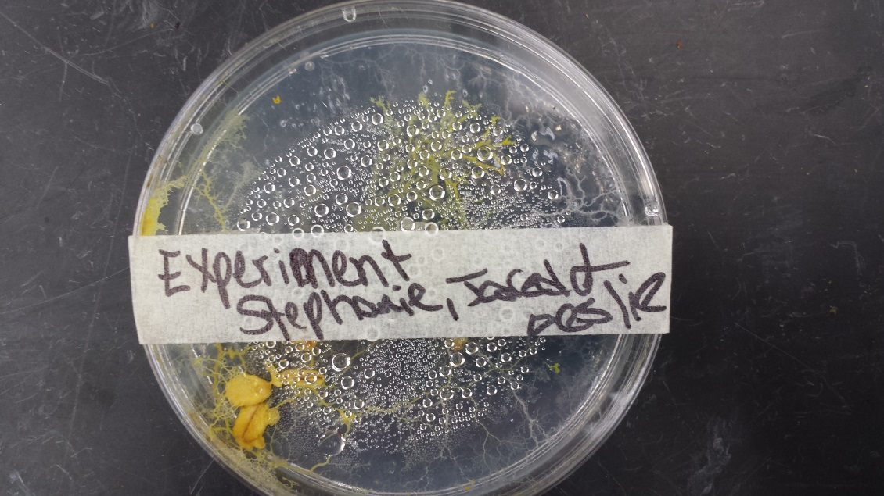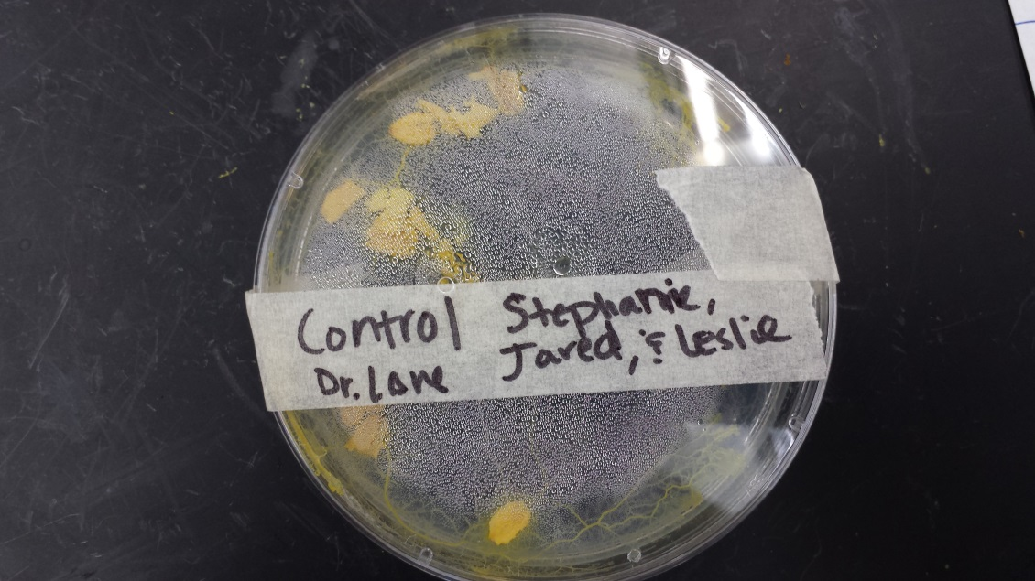

Day two: the subject has grown around the edge of the container, for both the experiment and the control, however it should be noted that the mold has shown more growth in the control than with the mixture variable. The oats are still covered and the mold has collected in the cracks of the sealed container

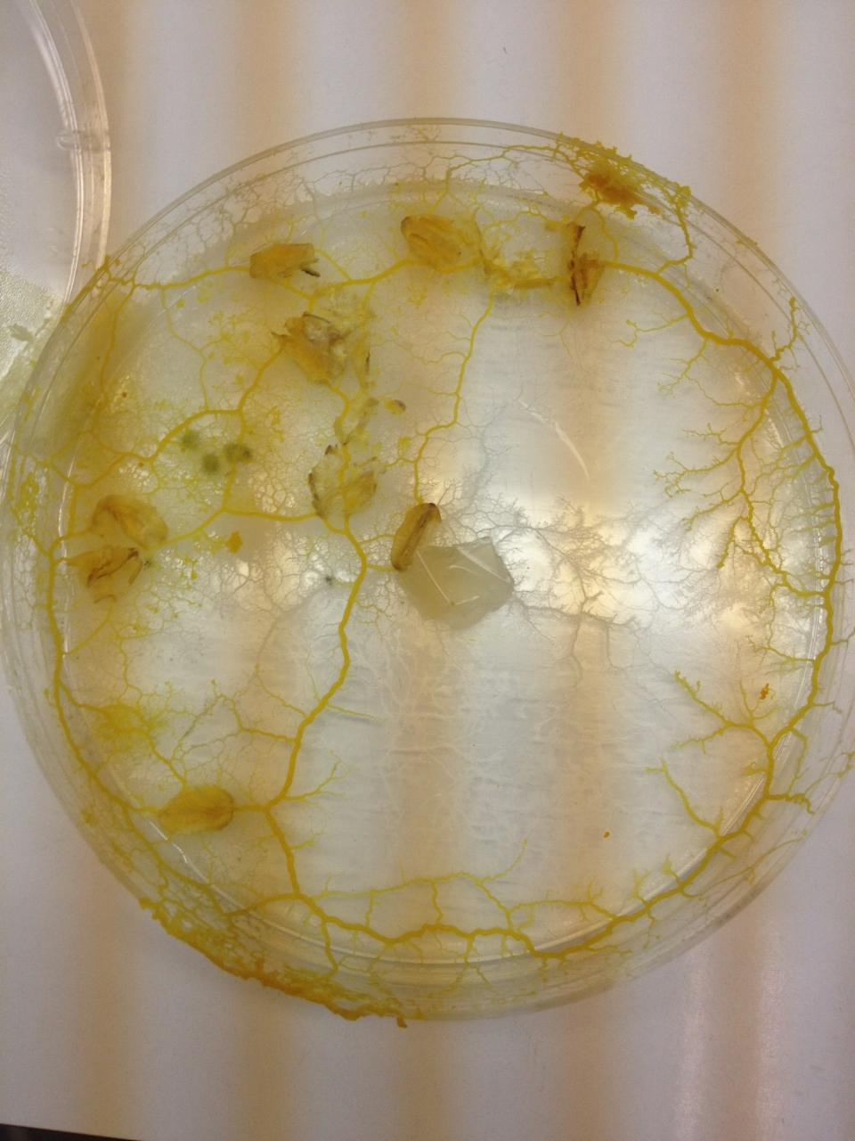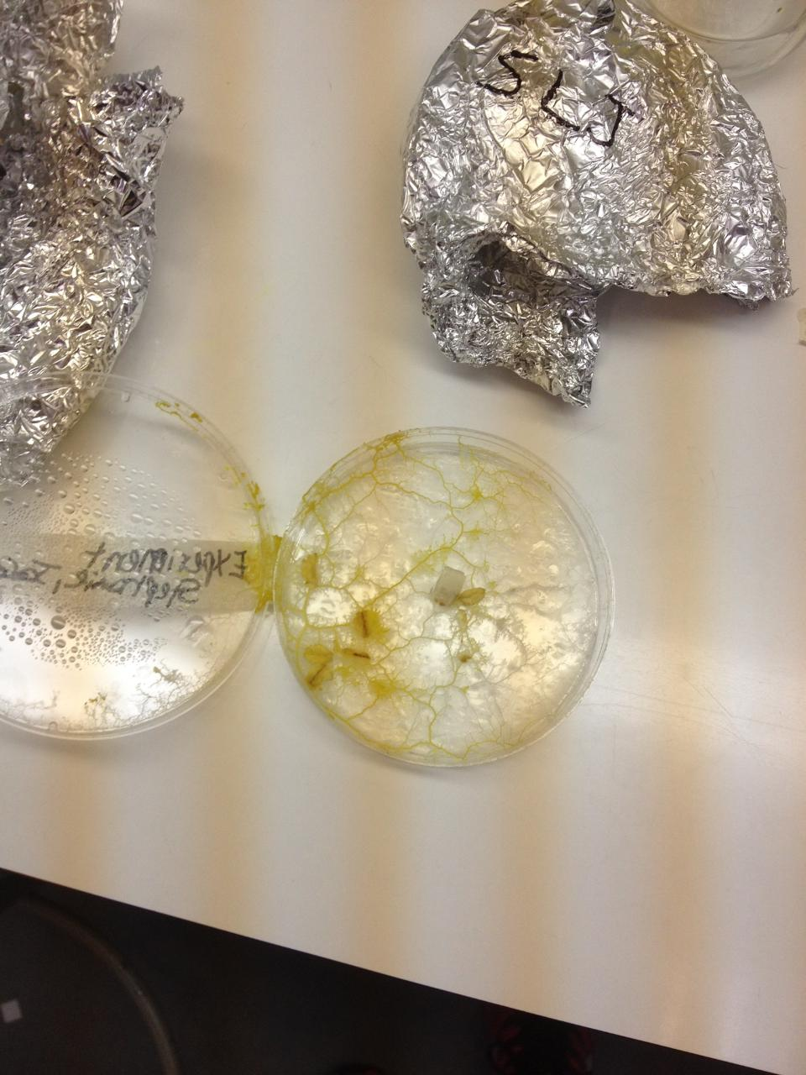
Day three: Significant increase of condensation in the control. The subject in the control has grown out of the container. Greater growth in the control has continued, in contrast to the experiment. Direct trails from the origin of the experiment placement to the nutrient-rich oats are still prominent in both containers. 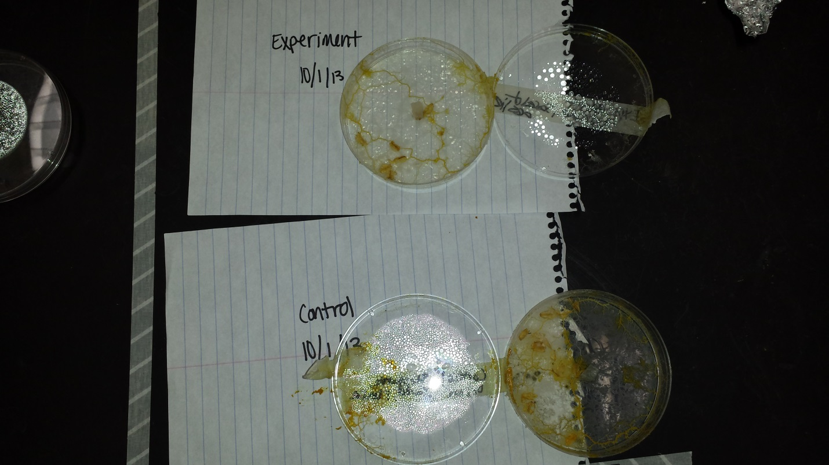
Conclusion: Given the evidence, it is safe to conclude that the extra mixture in the experiment does not promote growth of the mold. Instead, the mixture appears to have inhibited the growth of the mold, not only in its immediate contact, but even negatively affected the subject in its continuance of growth.

