Jared Purcell

/p/ intervocalic length 0.004 Mandarin 28 .4 milliseconds
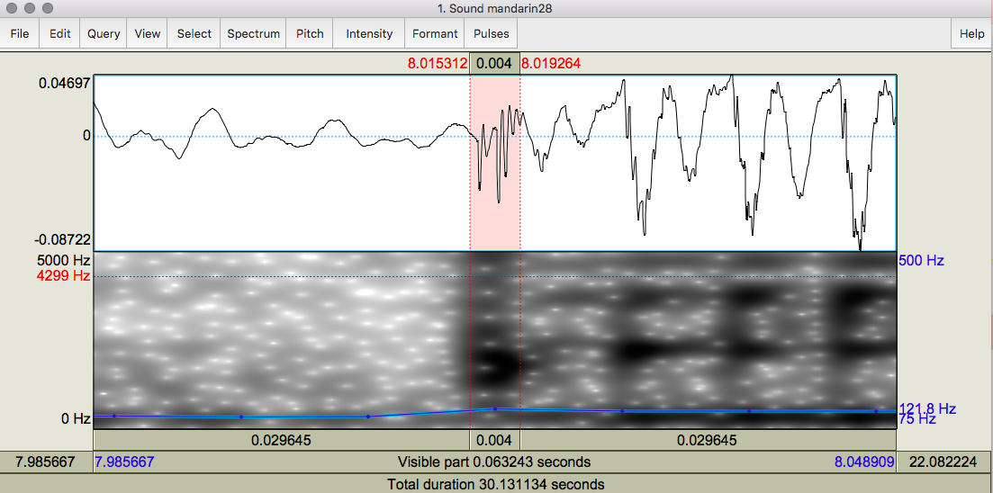

0.0400 seconds English1 4 milliseconds
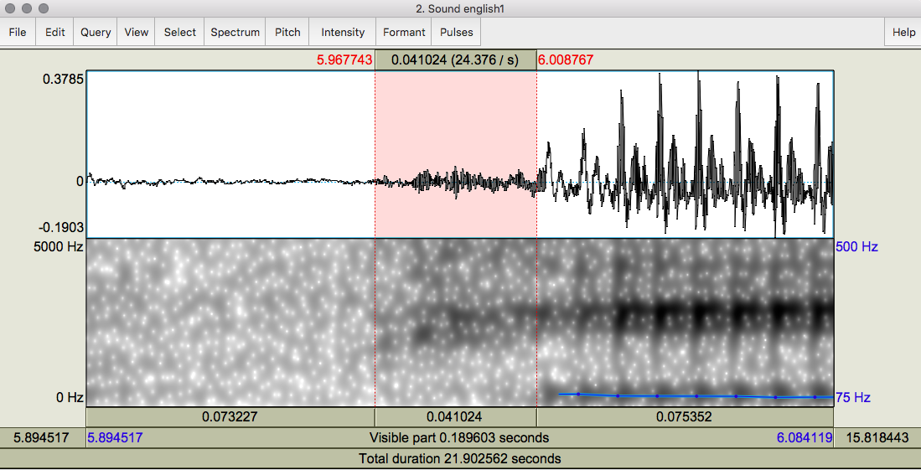
This kind of pattern makes it look like a continuant.
Referent by size to mandarin28 (see back)
