Jared Purcell
Mini-Report 3
50 points (undergrad) / 25 points (grad)
Due Friday 11/2, 11:59 p.m. (Blackboard)

- For each of your two languages, find and provide the following information:
i-Finnish ii-Estoninan
- For each of the following inflectional categories…
  - Is it marked morphologically in the language, syntactically/periphrastically, or which not at all?
    - . Finnish inflections are marked with suffixes and allow for free variant stylistic syntax. Because of Finnish’s synthetic behavior, the stress may shift in conversation to show emphasis or to show style. The language does not have an element of tone, and to compare with English, the tone of interrogative is represented in morphology /ko/ For example [ki:.tos] and [ki.to:s] are treated the same.
    - . Like, Finnish, inflectional features are entirely morphological, with combinational morphemes and ablaut behavior.
  - On what part(s) of speech is it marked?
    - & ii. Inflectional morphology is marked by suffixation in nouns, verbs, adverbs, adjectives, pronouns, and even clitics

  - Via what morphological process is it marked?
    - . Suffixes and clitics.
    - . suffixes, suffix-infixes, with gradation and vowel shifting.
  - How many sub-categories are distinguished (e.g., first, second, and third person; particular cases, etc.)?
    - . In Finnish there are 15 noun cases each with a set of plurality, that is, Nominative singular/plural, Genitive sin/pl, Partitive sin/pl, accusative, sin/pl; the 8-10 locative cases with sing/plural variance: Inessive, Elative, Illative, adessive, ablative, allative, essive, translative; some others are used in relation to negation and instrumental relation: instructive abessive, comitative, and evocative.
    - . Same in Finnish, 15+ noun cases, 10 cases for adverbs. First, second and third person with pluralities, and a ‘fourth person’ passive voice.
  - Give an example of each category that is distinguished morphologically or via a distinct type of periphrasis.

  - Person
    - . In verbs, person is inflected with a suffix. Because is the element of vowel harmony, there are minute differences with the third person plural. Examples below are from (Karlsson, 1999)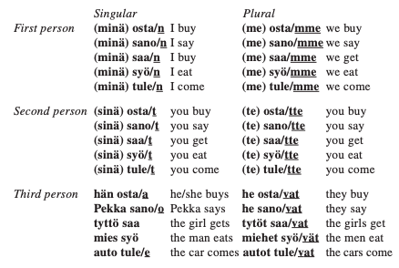

    - . Estonian has a 1st, 2nd, and 3rd person with corresponding pluralities.
(ekk, 2007: poordsona paradigma) /person paradigms/
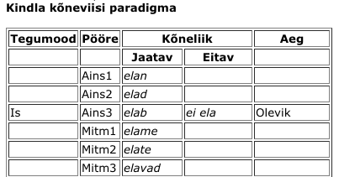
  - Number (plurality) (Kaarlson, 2015: §26)
    - . Finnish pluralities compared to the rest of other cases are relatively simple. As noted in the revised version of my work from exploratory exercise 2, plurality comes in different ways such as collectivity or partitivity.
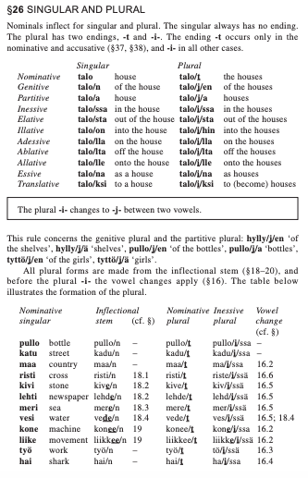
    - . (de Sivers, 1969) Estonian plurality is similar in its uniqueness in Finnish as a fixation between a declined stem and morpheme, minimal plural variation with consonant gradation and deletion with corresponding noun stems. It’s also marked by the partitive case and may fuse with associative and genitive cases, as mentioned in the second exploratory exercise. (Purcell, 2018:5) Plurality is used in formality, as represented in Indo-European languages. (Moseley, 2008:76)
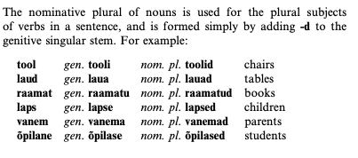
  - case
    - . infamously, Finnish ranges from a counted 14-2X cases depending on the count as a separation from plurality or split cases(Kaarlson, 2015: §24-51).
§26 above is representative of each case and its respective plurality for the gloss of “house.”
    - . Estonian has approximately (at least) 14 cases. The accusative case is ambiguous and associated with the Genitive case, a uniqueness in cased languages. Below is an example of simple declensions of nouns in Estonian from (Milijan, 2008:9).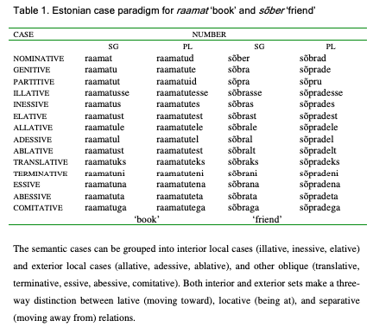
  - gender/noun class.
    - Finnish does not acknowledge “gender” in its language but instead has different formed pattern endings that are declined in different ways. <-i>, <-e>, <-C> Each are classified as different nominals called kieli, where the partitive is irregular, and the stem drops in declension; kivi, where the partitive singular is irregular and goes through consonant gradation in declension; and tunti, the most common that goes through partial consonant gradation but most consistent affixation. “-e” ending nominals are independent, and consonant endings are divided into subgroups: ihminen, ajatus, taivas, hyvyys, avain, tyoton,and lyhyt, all divided based on syllabary and endings. -inen, -s, -as, -on, and -yt (Kaarlson, 2015: §17-20).
    - . There is no particular case system or classification, but there are patterns of vowel shift and gradation that consistently occur between/with fixations.
  - Tense (Kaarlson, 2015: §59-63)
    - Finnish has 5 prescriptive marked tenses: present, past, perfect, pluperfect, and negation. Each of the tenses have 6 conjugations depending on the person perspective. Some are fusional in some circumstances with irregularities depending on phonetic environment.
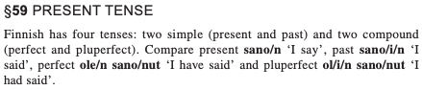
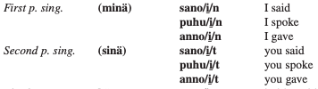
    - . Estonian has the same verb declension as Finnish: present, and past.
(Moseley, 2008:36) The parenthesized words are the short forms of pronouns.
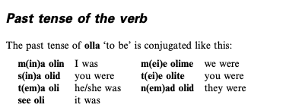
  - Aspect (Kaarlson, 2015: §68-72)
.
    - Finnish has active and passive voice represented in two styles of infinitives that equate to kind of verb perfection and imperfection. The passive has two endings: the passive marker itself, which is -tta-/-ttä- or -ta-/-tä-, and a special personal ending -Vn, e.g. sano/ta/an ‘one says, it is said’. Passive sentences should be distinguished from generic sentences expressing a general truth or law or state of affairs. In general, this following example is a good graph for variation for the morphology of verbs.
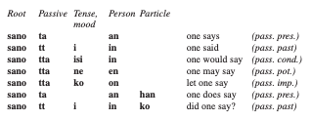
In addition,(Kaarlson, 2015: §61) provides examples of the perfect aspect morpheme. 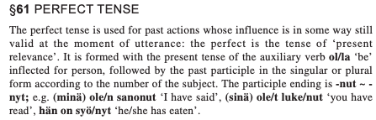
    - In Estonian, like Finnish, to reiterate, there IS NO conjugation for the future tense. There are the present, past and past aspects: perfect and imperfect. (Milijan, 2008:60). 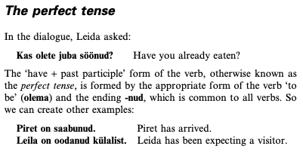
  - mood (Kaarlson, 2015: §64)
    - . Finnish has moods that are marked with suffixes. In general, the suffixes are labeled between the verb stem and the personal ending. There are more than 4 recognized, but only 4 are prescriptive: Indicative, Conditional, Imperative, and Potiential /-ne/.
** Conditional:-isi- jos = were morpheme followed by /if/ conj. ymmärtäisin jos puhuisit hitaammin =
"I would understand if you would speak more slowly"
** Imperative, with some variety comes with person variance.
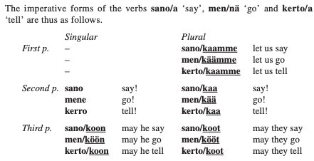
Potential, indicates that a verb is possible or conceivable where it would rationally be otherwise. -ne-
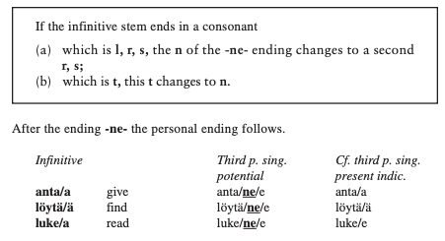
    - . Estonian, like Finnish has indicative, conditional, imperative and quotative. The following is an example of the imperative (IMP) case from (Milijan, 2008:pg84 ex16)
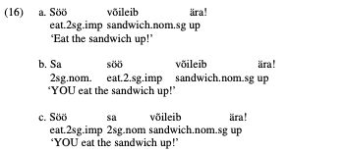
Voice –
i-. Finnic languages conjugate verb into the passive from the active by putting it into the “fourth person” verb, that is, “done by someone” For example, the fourth-person construction Ikkuna hajotettiin, with a transitive verb, means "Someone broke the window", while the third-person construction Ikkuna hajosi uses the anticausative and means “The window broke”. Voice is also referenced above in the ‘aspect’ section.
(Milijan, 2008: pg173 ex28)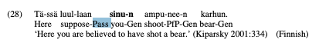
ii- .In Estonian, the passive is used also in the “‘fourth person’ someone,” (Moseley, 2008: 146)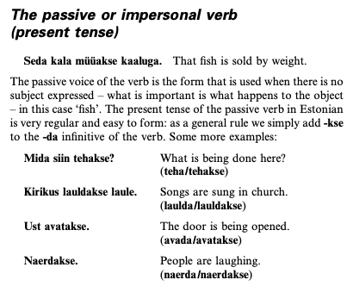
Interrogative clitic:: /ko/ in addition to the provided information on pronouns, the interrogative is an entirely different parallel in the language that declines with aspect ,tense, mood, and case. All of the forms have some construction of /k+V/

Works cited

de Sivers, Fanny. (1969). Analyse grammaticale de l'estonien parlé. Clermont-Ferrand: G. de Bussac.
(eek) Eesti keele käsiraamat. (2007). Eesti Keele Instituut http://www.eki.ee/books/ekk09/index.php?p=3&p1=5
Karlsson, F., & Chesterman, A. (1999). Finnish: an essential grammar. 2nd edition
Karlsson, F., & Chesterman, A. (2015). Finnish: an essential grammar. 3rd edition
Milijan, M. (2008) Grammatical Case in Estonian. School of Philosophy, University of Edinburg, Thesis.
Moseley, C. (2008) Colloquial Estonian The Complete Course for Beginners. Routledge.

