Jared Purcell
Professor Steven Weinberger
Linguistics 523: English Phonetics
December 11, 2018
QUIZ 3
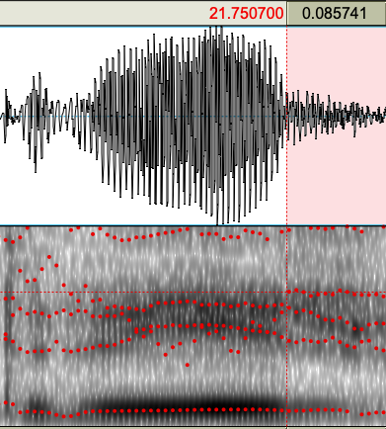
a.
1 <STELLA> [ɛstɛ̝lə] prothesis and vowel shortening.
2 <FROM> [frʌn] n-assimilation to d
3 <PEAS>[pʰis]
4 <SCOOP>[skup̬]
5 <THREE>[ t̬riːʃ] stopping and there’s a less-voiced fricative coda >

b. /pʰ/ .0.02 milliseconds

c & d. Consonantal: I. interdental fricative (theta) stopping. Theta does not within of the phonetic inventory of (spa) and is approximated with dental stops. <these things with>, <thick>, <these><the>
II. r to trill. The alveolar approximate in not in the (spa) inventory and replaced by the /r/ alveolar trill. <her> <fresh><her><brother><frog> <red><her> <train>. However the approximate occurs once in <store>
Vowel I. vowel heightening, [i] occurs in (spa) where [ɪ] does not. Syncope (except schwa), Median vowels are shortened in the cases id <for><and maybe> <toy><with>
II. Monopthization
Syllable Structure I. CCVC or CVCC spa is CV
Prothesis: Speaker 79 Spanish prohibits an onset cluster of #sC/, and epenthesis occurs before the word in order to accommodate. /#esV/ this is observed in <spoons>,<stella>,<slabs>, <snow>
This does not occur is <a small> due to the schwa being an article and no previous coda.
II. Elision for final consonants <of> the labiodental fricative <five> /v/ <brother> alveolar approximate, <and> /d/ <of fresh> occurs because the following onset syllable preserves it in assimilation. <snack for her> has weakened mid-vowel nucleus and coda.

e. prothesis is the most problematic speech pattern for English speakers because it can have several types of miscommunication for syntax and lexical recognition. It doesn’t occur in any other variety of L1 English, whereas the other speech patterns do in other L1 dialects. The epenthesis in a whole phrase may cause a syntactic issue with articles, nominalization. Elision, the deletion of final consonants also occurs in native English dialects. I will also argue that vowel differentiation has more flexibility per dialect and there are not complete fronting or backing of vowels, such the difference between prince and prance, effect and affect, or any ablaut construct. The same argument of native dialectal acceptance applies to theta stopping. Trilling is noticeable by native speakers if held for more than a tap or two (not noticed in this sound piece), and then it is allophonic, in that is it still interpreted as an orthographic <r>.
Theoretically, learning that the unnecessary addition of these vowels will give the speaker a comfort and perspective to the overall eng sound patterns and syllabic structure.

