Jared Purcell FINNISH
LING 686: Morphology Fall 2018
Schreiner Mini-Report 4 50 points (undergrad) / 25 points (grad)

Due Friday 11/20, 11:59 p.m.
• For each of your two languages, find and provide the following information on morphosyntax and morphophonology

1. Transitivity/valency:
impersonal: This occurs with the application with the 4th person verb conjugation that is added in verbs to create a style of ambiguity. This also has a variable passive voice, because the 4th person is sometimes described in context as ‘someone.’ In this report, I have taken data that I’m familiar with and processed it through FINTWHOL.

intransitive: / The bags went through a change/ The bags were changed/ laukut vaihtuivat/
"<laukut>" / bags/ "<vaihtuivat>" / to change/
"laukku" N NOM PL "vaihtua" V PAST ACT PL3
transitive: the syntax is inverted in a transitive clause for a change to VS(O) bags were changed.
“vaihdoimme laukkuja”
"<vaihdoimme>"/to change "<laukkuja>"/bags/
"vaihtaa" V PAST ACT PL1 "laukku" N PTV PL
ditransitive: This is an example of standard SVO in Finnish /he gave her the flower/
(staggered for space)
“Hän antoi hänelle kukan.”
"<hän>" He/she/
"hän" PERS PRON NOM SG
"<antoi>" to give
"antaa" V PAST ACT SG3
"<hänelle>" receipient pronoun to her, Note: not DATIVE
"hän" PERS PRON ALL SG
"<kukan>"
"kukka" N GEN SG
Tritransitive: To gloss /He bet him a dollar on a horse/, the coordinating conjunction is used with an allative pronoun followed by a GEN-NOM in order to form the relationship from the verb. A conservative translation would be / (He/she) guessed with her/him (a)dollar (on/of) a horse.
“Veikkaan että hänelle dollarin hevonen”
"<veikkaan>"
"veikata" V PRES ACT SG1
"<että>"
"että" COORD C
"<hänelle>"
"hän" PERS PRON ALL SG
" <dollarin>"
"dollari" N GEN SG
"<hevonen>"
"hevonen" N NOM SG
a. What alignment pattern does your language follow?
-Nominative-accusative (all subjects marked one way, objects marked another way) –
Finnish is based on a case system that marks parts of speech with suffixes in relation to other. Nominative-accusative is the simplest relationship; Nominitive-genitive marks animacy and genus-species but also works as a special relationship as an object part of the sentence. Nominative relates to partitive, accusative, and dative. However, dative-ness is also marked with different locative, allative cases. These different cases style different styles of transitivity (or lack of) in relation to verbs.
The accusative and partitive in Finnish works hand in hand where the accusative would entail the entire part of the object or a negative relation to an object, and the partitive would be anything that isn’t the ‘whole’. In the examples below, the fox plays chess. Since the game is played with another, only a part of chess is played, it is considered partitive.
kettu pelaa shakkia.”
"<kettu>" "<pelaa>" "<shakkia>"
"kettu" N NOM SG "pelata" V PRES ACT SG3 "shakki" N PTV SG

The accusative is used specifically if the indirect object is identified as ‘one’ or ‘whole’, or the action will for sure happen. (there is no future tense, but this implies a FUT attribute). Some examples follow below. Interesting however, the examples provided on the grammar source are identified as GEN in the University of Helsinki FINTWOL morpheme splicer due to a -<n> suffix. Also note that the accusative and genitive cases have semi-fused morphemes. Accusative and partitive share -t; genitive and accusative share -n; Nominative and accusative share – ø (null).
These are examples from (Holsteyn, 2007: accusative 1.1-1.3)

Accusative denoting ‘one’
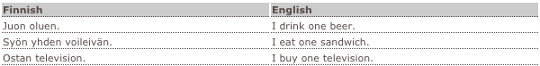
Accusative denoting ‘future’ ‘determined’ 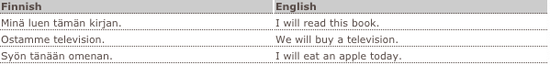Accusative denoting ‘whole’ 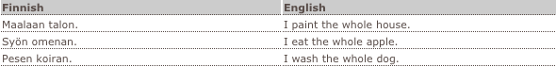

Split (e.g., N-A in some aspects, E-A in others) -Some other alignment Remember, your language may do this with case or some other kind of morphosyntactic marking, or (like English) with word order. Because of the diverse case system, the SVO word order may change.
In the bag changing example above, the language changes word order with indirect passivity in all places else, examples show SVO. Colloquially, the verb marks person and plurality, so the subject is often deleted making the utterance more (sV)O. In interrogatives, the syntax may be inverted because the first segment followed by the interrogative clitic -ko is attached, therefore the structure may take any theoretical form. Examples of this are in the clitic section below.

b. Are there other special markings or patterns for transitivity—e.g., a transitivizing morpheme that attaches to intransitives?

There is an ablaut (and vowel insertion) that changes for transitivity in Finnish verbs. There are two main structures for this aspect, -u-/-y- and utu/yty, vowel heightening to the front and back depending on the harmony of the vowel type: <y> for umlauted front vowels and <u> for back vowels. The latter form where the vowel is repeated <utu> and <yty> means to do something oneself.
The following examples are derived from the ‘uusikielemee’ grammar site (Holsteyn, 2007)
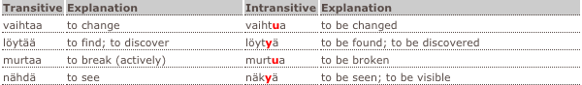
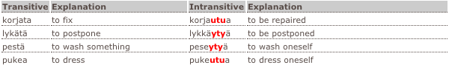

c. How are ditransitives formed?
Ditransitives are formed with different word order for a slight variation of pragmatic. The indirect object is marked with an allative suffix and the direct object is marked with the accusative. In this simple construct, the prosodic emphasis is based on what is more proximal to the verb. For a sample construction, Kaiser gives the following examples: (Kaiser, 2000).
(1)a. (IO-DO) Minä annoin miehelle kirjan.
I-NOM gave man-ALL book-ACC.
‘I gave a/the man a/the book.’

(1)b. (DO-IO) Minä annoin kirjan miehelle.
I-NOM gave book-ACC man-ALL.
‘I gave a/the book to a/the man.’

2. Voice/valency-changing operations: What valency-changing categories/operations does your language have? (passive, anti-passive, causative, applicative, benefactive, etc.) How do they appear (case? word order? auxiliaries? etc.)
Reduction, the only voice change in Finnish is the passive and the varieties within:(Holsteyn, 2007: The Passive)
Junassa luetaan usein kirjoja.
Junassa luetaan usein kirjoja.
Juna.N.INE.SG lukea.V.PRES.PASS.4PE ADV N.PTV.PL
Books are read on the train.//
Who exactly is doing the reading is not important.
This still follows the (sV)O pattern.
Here is the process to passive from the infinitive, Verb type 1: weak stem + -taan/-tään
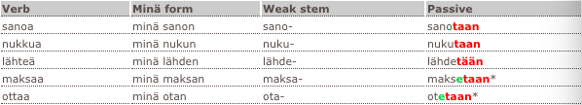
*when the infinitive ends in -aa, it becomes -e in the passive form.
Verb types 2, 3, 4, 5 and 6: infinitive + -an/-än
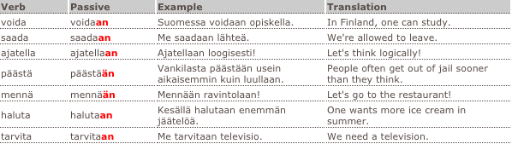

(After a reasonably thorough search, I can say that there are no other voices, unless we account for the imperative)

3. Clitics: Does your language employ clitics? What do they do? Do their forms change (i.e., do they agree with anything)? Where do they attach?

Yes, Finnish utilizes four discourse clitics: the interrogative with a clitic -ko or -kö depending on the front or back vowel harmony, defined by the first lexeme in the utterance (word in the sentence); the clitic is designed to be to signal a polar question. -pas is meant to cling to the of the subject to the object. -han has a reminding feature. The last is not required to attach to the first constituent of a clause and is glossed as an emphasis, ‘also’ or ‘even’. Examples of all are below, (Ranta, 2012)

Jussi juo maitoa (no clitic, neutral): “John drinks milk”
Jussiko juo maitoa (ko, question): “is it John who drinks milk”
Jussipas juo maitoa (pas, contrasting): “it is John who drinks milk (and not Peter)”
Jussihan juo maitoa (han, reminding): “as we know, John drinks milk”

Jussikin juo maitoa nykyaan (subject) also John drinks milk nowadays (and not only Peter)”
Jussi juokin maitoa nykyaan (verb) “John even drinks milk nowadays (and not only produces)”

4. Allomorphy: What kind of allomorphy, if any, does your language display? Explain the rules and give examples (Ivonen, 2005).

a. assimilation (what kind?) Universal nasal assimilation, velrization, labialization.

b. dissimilation: in compounds where two vowels would meet at the ends of stems, the vowels will be separated by a glottal stop. /V + V/ → /VʔV/. kuorma-auto /kuo̯rmɑʔɑwto/

c. harmony (vowel, consonant)
All words are bound to vowel harmony as front and back vowels, this affects fixations. The harmony is observed in the language’s orthography with an umlaut diacritic on fronted vowels.
d. gemination: in compound boundaries, the post-vocalic fricatives are geminated into approximates. This occurs with the imperative mood suffix: osta vene /o̞stɑʋːene/ ('buy a boat')

e. palatalization
The plural changes depending on its environment. On the final coda, the plural is -t; when the environment is intervocalic, <i> is palatalized to <j>; elsewhere the plural morpheme is /i/.
This is observed in the chart below provided by (Kiparsky, 2001).

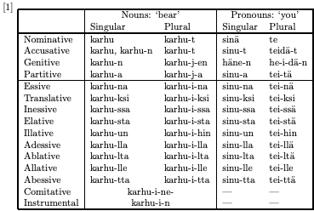

f. other: I mentioned earlier about the fusion of suffixes -n and -t regarding the Accusative, Genitive, and Partitive cases. Kiparsky argues that these are allomorphs because they conform to the same morphological case and are dissimilar in an abstract case (Kiparsky, 2001).

CITATIONS

Holsteyn, H. (2007). Uusi kielemme - Finnish for Busy People. http://www.uusikielemme.fi
Holmberg, A. (2008) The Syntax of the Finnish Question Particle. Lingbuzz. https://ling.auf.net
Kaiser, E. (2011) The Syntax-Pragmatics and Finnish ditransitive Verbs. MITWPL, Cambridge, Mass
Kiparsky, P. (2001). Structural case in Finnish. Lingua, 111(4–7), 315–376. https://doi.org/10.1016/S0024-3841(00)00035-8
Iivonen, A.; Harnud, H. (2005), Acoustical Comparison of the Monophthong Systems in Finnish, Mongolian and Udmurt", Journal of the International Phonetic Association, 35 (1): 59–71, doi:10.1017/S002510030500191X
Ranta, A. (2012). On the Syntax and Translation of Finnish Discourse Clitics. In D. Santos, K. Lindén, & W. Ng’ang’a (Eds.), Shall We Play the Festschrift Game? (pp. 227–241). Berlin, Heidelberg: Springer Berlin Heidelberg. https://doi.org/10.1007/978-3-642-30773-7_14

